**TITLE OF LAB: (BJT BAISING CIRCUITS FIXED BAISED CONFIGURATION)**

**Lab No. #09**



**Spring 2022**

**CSE-206L Electronic Circuits Lab**

Submitted by

**Safi Ullah Khan : 20PWCSE1943**

Class Section: **B**

“On my honor, as student of University of Engineering and Technology, I have neither given nor received unauthorized assistance on this academic work.”

Student Signature: ______________

Submitted to:

**Engr. Abdullah Hamid**

(Monday, June 19th, 2022)

**Department of Computer Systems Engineering**

**University of Engineering and Technology, Peshawar**

**Objectives:**

* To determine the quiescent operating conditions of the fixed-bias BJT configuration.

**Equipment:**

* DC Power Supply
* DC voltmeter
* DC Ammeter

**Components:**

* Resistors: 2.7 k, 1 M
* Transistors: 2N3904, 2N4401

**Theory:**

* **Biasing of the bipolar junction transistor (BJT)** is the process of applying external voltages to it. In order to use the BJT for any application like amplification, the two junctions of the transistor CB and BE should be properly biased according to the required application. Depending on whether the two junctions of the transistor are forward or reverse biased, a transistor is capable of operating in three different modes.

**Cutoff Mode of BJT:**

* The BJT is fully off in this state. In the cutoff mode both the base emitter, BE as well as collector base CB junction is reverse biased. The BJT is equivalent to an open switch in this mode.

**Saturation Mode of BJT:**

* The transistor is fully on in this state. The CB as well as BE junctions are forward biased. The BJT operates like a closed switch in the saturation mode. If a BJT is in saturation mode than it should satisfy the following condition,
* Where, βDC is common emitter current amplification factor or current gain.

**Active Mode of BJT**

* In order to use the transistor as an amplifier, it must be operated in the active mode. The BE junction is forward biased whereas the CB junction is reverse biased. Figure below shows both n-p-n and p-n-p transistors biased in the active mode of operation.

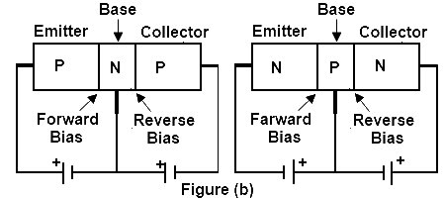

**Biasing Circuits of BJT:**

To make the Q point stable different biasing circuits are tried. The Q point is also called as operating bias point, is the point on the DC load line (a load line is the graph of output current vs. output voltage in any of the transistor configurations) which represents the DC current through the transistor and voltage across it when no ac signal is applied. The Q point represents the DC biasing condition. When the BJT is biased such that the Q point is halfway between cutoff and saturation than the BJT operates as a CLASS-A amplifier. The three circuits or biasing arrangements which are practically used are explained below.

**Fixed bias (base bias):**

This form of biasing is also called *base bias or fixed resistance biasing*. In the example image on the right, the single power source (for example, a battery) is used for both collector and base of a transistor, although separate batteries can also be used.

In the given circuit,

Vcc = IbRb + Vbe

Therefore,

Ib = (Vcc − Vbe)/Rb

For a given transistor, Vbe does not vary significantly during use. As Vcc is of fixed value, on selection of Rb, the base current Ib is fixed. Therefore, this type is called *fixed bias* type of circuit.

Also, for the given circuit,

Vcc = IcRc + Vce

Therefore,

Vce = Vcc − IcRc

The common emitter current gain of a transistor is an important parameter in circuit design, and is specified on the data sheet for a particular transistor. It is denoted as β on this page.

Because

Ic = βIb

we can obtain Ic as well. In this manner, operating point given as (Vce, Ic) can be set for given transistor.

**Advantages:**

* The operating point is set by a single resistor RB and the calculation is very simple.

**Procedure:**

* Construct circuit as of *Fig.1* using 2N3904 transistor and set VCC = 20 V.
* Measure the voltages VCE. Record it in table
* Calculate the resulting base current, IB and collector current, IC. Using the values obtained, find β.
* Now simply remove the 2N3904 transistor and replace with 2N4401 transistor.
* Again, measure the voltages VCE. Using the same Method, calculate the values of IB and IC. From the values obtained, determine the β value for 2N4401 transistor.
* Calculate the magnitude (ignore the sign) of the percent change in each quantity due to a change in transistors.

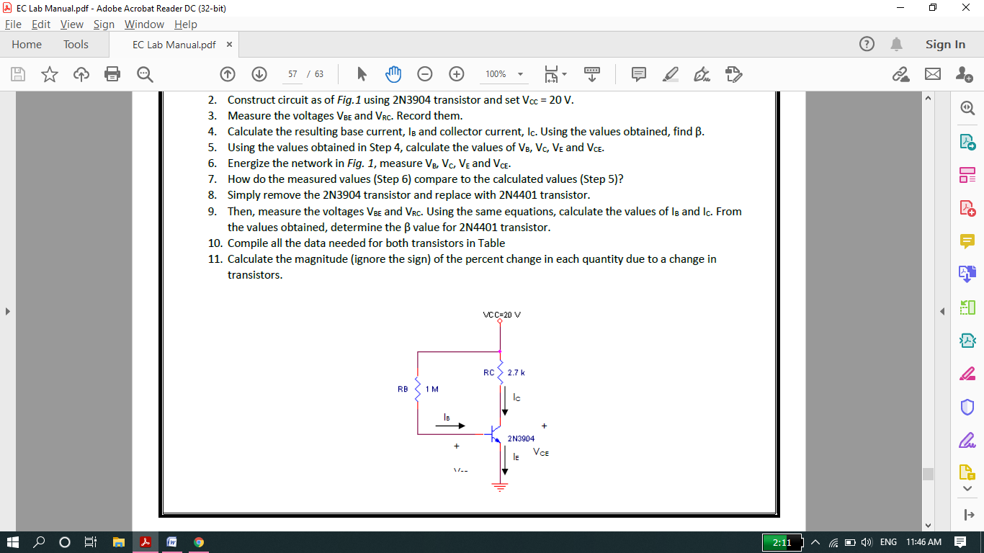

**Different Formulas:**

* IB=VRB/RB=VCC-VBE/RB
* IC=VRC/RC=VCC-VCE/RC
* VCE=VCC-VRC
* VBE=VCC- VRB
* VRC=IC/RC
* VRB=IB/RB
* Alpha=IC/IE.
* Beta=IC/IB.

**NOTE:**

* In proteus we calculate IB, IC VRC and VRB directly using DC Ammeter and DC voltmeter. But we can also calculate these parameters using above formulae.
* VBE is voltage across base and emitter terminals of transistor. Similarly, VCE is the voltage across collector and emitter terminals of transistor. We can also calculate these values directly using DC voltmeter connecting across collector emitter and Base emitter.

**Formulae for finding Percent change Due to change in transistor:**



**Calculation:**

* In this lab we will calculate VCE, IB, IC and beta for two different transistors then we will find %error.

**Calculated: Transistor 1(2N4401):**

* IB = 19.5 μA
* IC = 3.04 mA
* VCC=20v
* VRC=8.21V
* VCE = VCC-VRC=20-8.21
* VCE=11.79v
* Beta=IC/IB=155

**Schematic Circuit:**

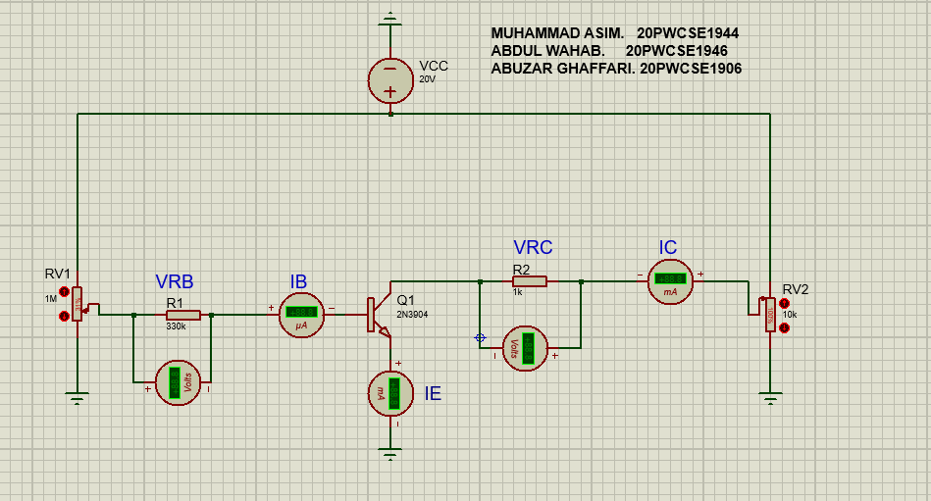

**Calculated: Transistor 2(2N3904):**

* IB = 19.5 μA
* IC = 3.32 mA
* VCC=20v
* VRC=8.98v
* VCE = VCC-VRC=20-8.98
* VCE=11.02v
* Beta=IC/IB=170

**TABLE:**

|  |  |  |  |  |  |
| --- | --- | --- | --- | --- | --- |
| Transistor-Type | | VCE(V) | IB(μA) | IC(mA) | β |
| 2N4401 | 11.79 | | 19.5 | 3.04 | 155 |
| 2N3904 | 11.02 | | 19.5 | 3.32 | 170 |

**Percentage ERROR in Each Quantity:**

* We will ignore –ve sign of %age error.

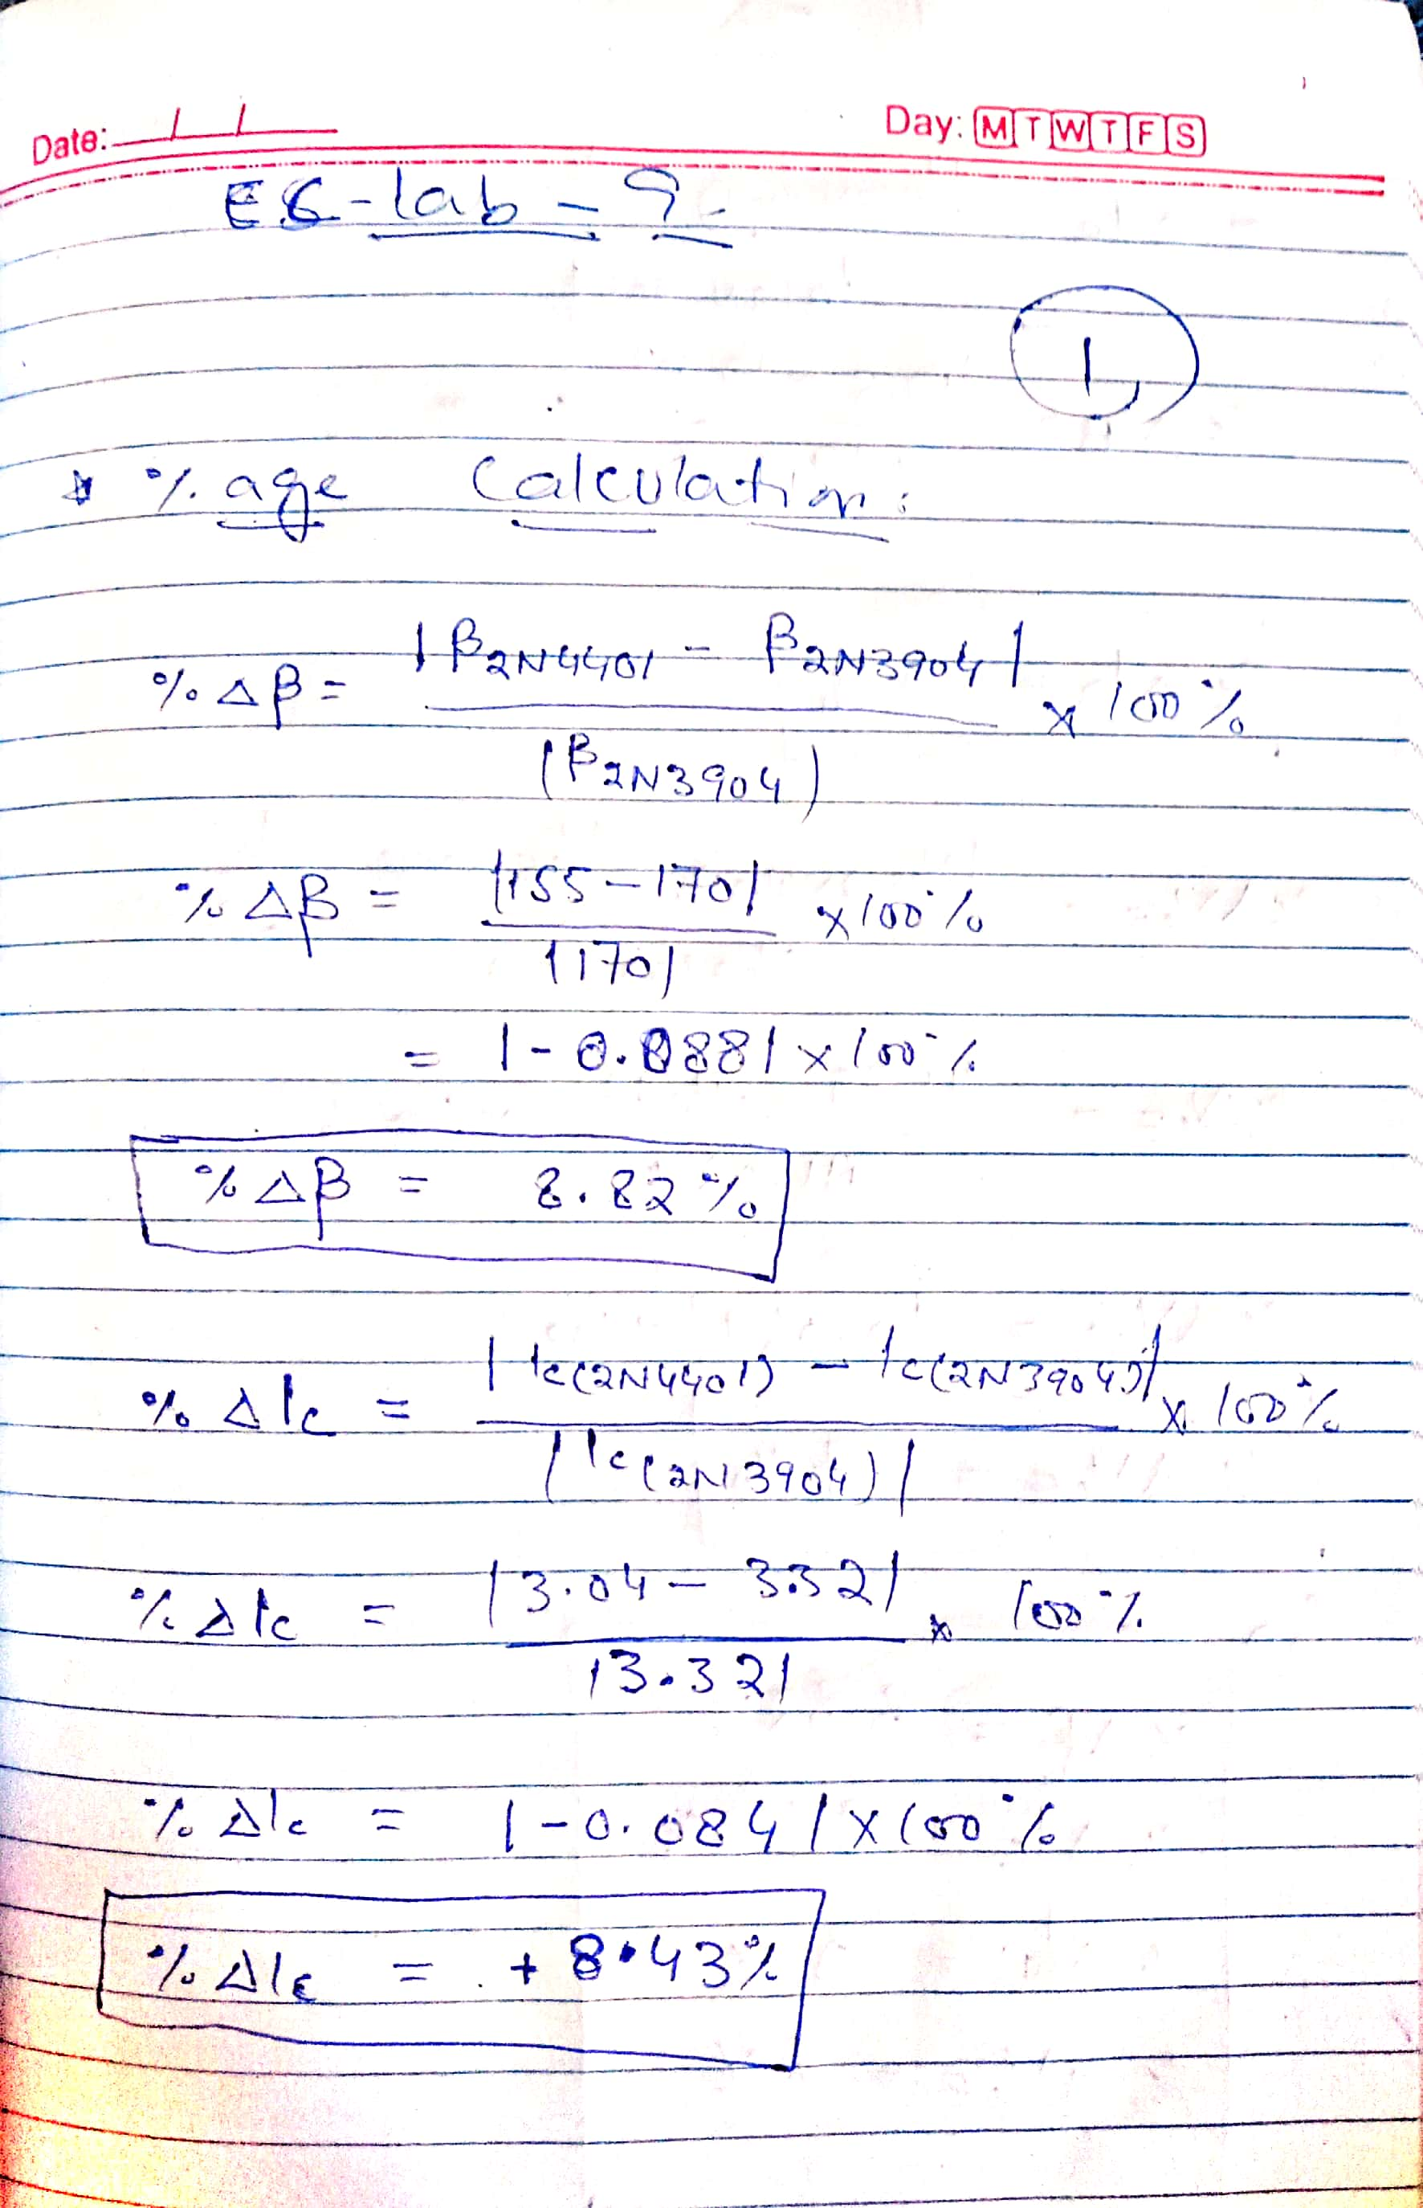

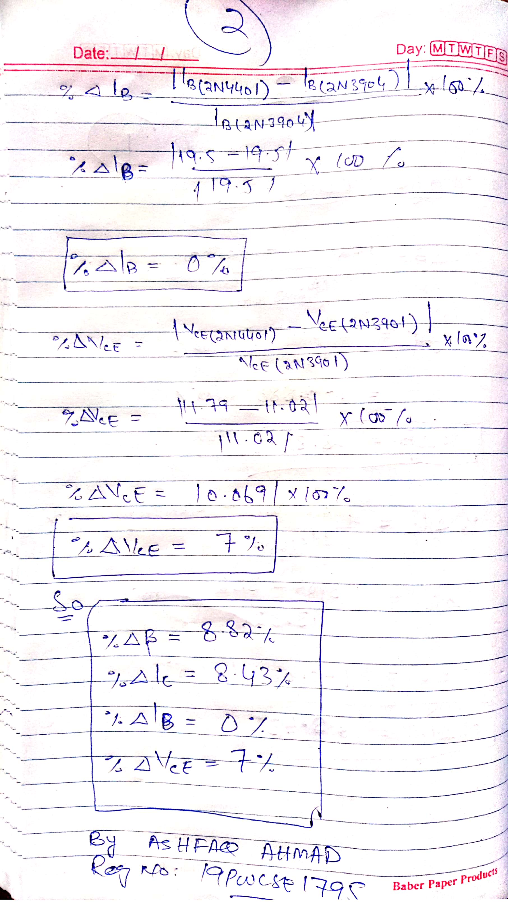

**---------------------------------THE END-------------------------------**